SYLLABUS

- SCHEDULE

8/9 | 15/9 | 22/9 | 29/9 | 6/10 | 13/10 | 20/10 | 27/10 | 3/11 | 10/11 | 17/11 | 24/11 | 1/12 | 8/12
Intro.  Unit 5 | Self-study | Unit 6 | Self-study | Unit 7 | Self-study | Unit 8  Midterm test | Self-study | Unit 9 | Self-study | Unit 10 | Self-study | Review | Self-study

- CONTENTS

 | Grammar | Vocabulary | Reading | Listening | Writing | Speaking | Extra activities (optional)
Unit 5 | - Can/ can’t  - Simple present v.s. Present continuous | - verb phrases  - weather & seasons | Scanning | Listening for details | Writing a Facebook post | Talking about leisure activities in different seasons | Practical English: Buying clothes
Unit 6 | Object pronouns | - dates and numbers  - music | Matching information | Listening for details | Writing an informal email | Talking about music and preferences | Review and check: Unit 5-6
Unit 7 | Simple past | - word formation  - go, have, get | Skimming | Listening to a song | Writing s short narrative paragraph | Talking about past events | Practical English: Asking for directions
Unit 8 | There + be | - the house  - prepositions : place and movement | Guessing meaning of unknown words out of context | Listening for gists | Writing a short descriptive paragraph | Describing the house | Review and check: Unit 7-8
Unit 9 | - Countable/ Uncoutable nouns  - Comparative adjectives | - food  - food containers | Scanning | Listening for details |  | Talking about food | Practical English: Ordering a meal
Unit 10 | - Superlative adjectives  - Be going to | - places & buildings  - vacations | Scanning |  | Writing a formal letter | Role play | Review and check: Unit 9-10

- ASSSESSMENT

- Fifteen-minute test: Online exercises
- One-period-test: Midterm test
* Pluses: frequent attendance, active participation, homework completion

Step 1: https://www.schoology.com/
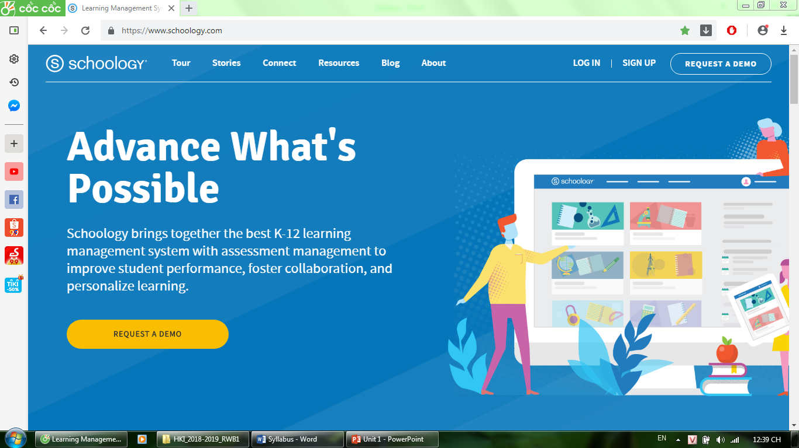

Step 2: Sign up Student
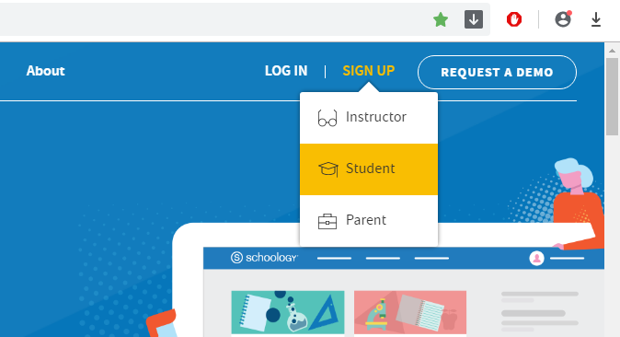
Step 3: Access code: RQRT-T6W6-M5MMC Click “Continue”

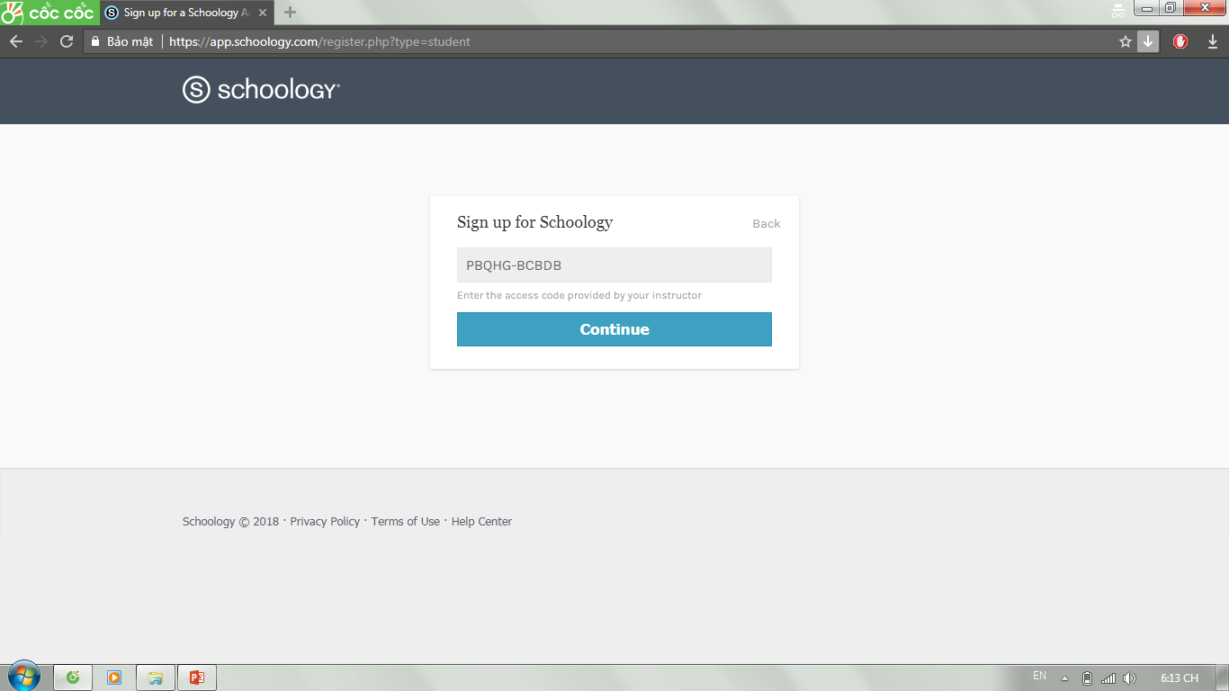

Step 4: Fill out the form Click “Register”


